OSOBNÍ VÁHA

7730.65

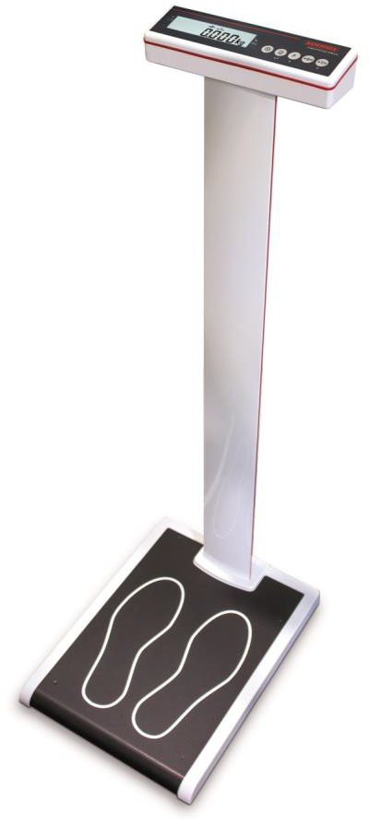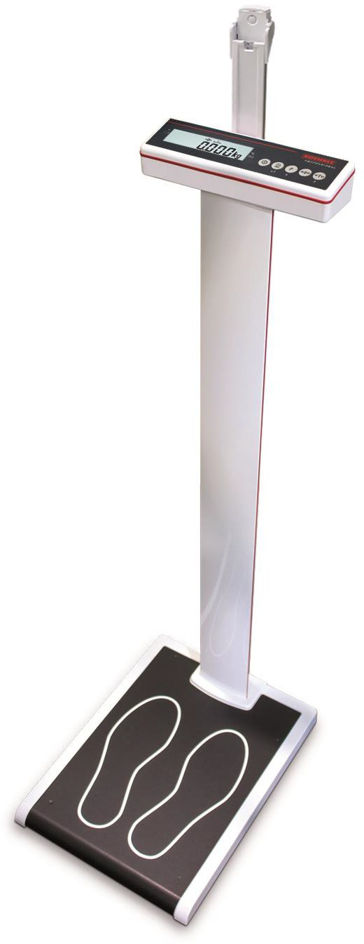

Návod k obsluze



OBSAH

1. SUPPLIED SCOPE 32
   1. Optional Accessories 32
   2. Product Description 32
2. GENERAL INSTRUCTIONS 34
   1. Technical Specifications 34
   2. Intended uses 34
   3. Classification 35
   4. Bezpečnostní in 35
   5. Cleaning 36
   6. Maintenance and service 36
   7. Guarantee / Warranty / Liability 37
   8. Disposal of Standard Batteries and Rechargeable Batteries 37
   9. Scale Disposal 37
3. APPROVAL 38
   1. CE marking 38
   2. Explanation of Symbols on the Packaging 39
4. SETTING UP THE SCALE 40
   1. Scale setup and startup 40
   2. Mounting the length rod (version 7730.65.002) 40
   3. Power supply 41
   4. Switch on 42
   5. Vážení 42
   6. Tárování 42
   7. Funkce Hold 43
   8. Printing / IT interface (with optional RS232 interface) 44
   9. Alibi memory (option for verifiable data transmission) 44
   10. PLU memory (e.g. saving various tare weights) 45
   11. Infant weighing 46
   12. Zero reset 46
   13. BMI-function 46
   14. Operating the length gauge (version 7730.65.002) 47
   15. Switch off / Shutting down safely 48
5. MALFUNCTIONS – CAUSES AND REMEDIES 49
6. NOTICES CONCERNING ELECTROMAGNETIC COMPATIBILITY 50

Thank you for your purchase of this Soehnle Professional product. This product has been equipped with all state of the art features and is optimized for easy operation. If you have questions or experience problems with your unit that are not addressed in the user manual, please contact your Soehnle Professional service partner or visit us over the Internet at [www.soehnle-professional.com.](http://www.soehnle-professional.com/)

# SUPPLIED SCOPE

|  |  |  |
| --- | --- | --- |
| Model | 7730.65.001 | 7730.65.002 |
| Osobní váha | ✓ | ✓ |
| Napájení | ✓ | ✓ |
| Návod k obsluze | ✓ | ✓ |
| Baterie Mignon AA, 1,5 V (6x) | - | - |
| Mechanické měření výšky | - | ✓ |

## Příslušenství

|  |  |
| --- | --- |
| 2795.12.001 | Thermo-direct label printer - 150 mm/s |
| 2795.20.001 | Thermo-direct label printer - 178 mm/s |
| 2795.14.001 | Receipt printer, graphics-compatible 9-pin printer |
| 2550.03.002 | Data transmission cable to connect to a PC |

## Popis produktu

Osobní váha, conformity rated 7730.65

A



Obrázek produktu zobrazuje:

B

|  |  |
| --- | --- |
| A | Mechanické měření výšky |
| B | Displej |
| C | Vážící platforma |

C



1. VAROVÁNÍ

* Contact your dealer or the manufacturer in the event of a malfunction. Unauthorized modifications or repairs can damage your scale and can cause the manufacturer's warranty to be null and void.
* Do not allow displays to get wet. Liquids (e.g. water) can damage the displays. Use a dry cloth, e.g. a towel to dry off the display.
* Disconnect the device from electrical power prior to installation, cleaning, or service. The device can otherwise sustain damage.
* If the display is not used for an extended period, disconnect the scale from power or switch off the display when in rechargeable battery mode. Recharge the battery no later than after 4 weeks to compensate the self-discharge.
* Avoid stacking materials on the display or loading the display with weights. This can result in damage.
* Position the scale on a firm, stable, and level surface to ensure accurate measurements.

Measurement results will deviate on carpeting or inclines.

* Do not connect the display to an unstable power supply.
* Only use the original equipment. Using products made by other manufacturers can damage the display.
* Do not touch the interface and patient at the same time
* Remove batteries if scale is not used for a long time.

# GENERAL INSTRUCTIONS

## Technická Specifikace

|  |  |  |
| --- | --- | --- |
| Model | 7730.65.001 | 7730.65.002 |
| Vážící rozsah: | 300 kg | 300 kg |
| Dílek: | 100 g | 100 g |
| Length measurement range: | - | 110 – 210 cm |
| Tolerance length gauge |  | ± 10 mm |
| Rozměry (mm) | 365 x 490 x 1,140 | 365 x 490 1,270 |
| Hmotnost produktu: | 15.6 kg | 16.4 kg |
| Power supply: | 100 - 240 V  50 - 60 Hz, 250 mA  (Mains adapter, item no.: 2557.05.002 (618.020.097) | |
| Approval class: | Approval class III, MPG class 1m | |
| Provozní teplota: | + 10 °C to + 40 °C | |
| Storage temperature: | - 20 °C to + 65 °C | |
| Vlhkost: | 20 % to 85 % relative humidity, non-condensing | |
| Air pressure: | 950 to 1.050 hPa | |
| Optional: |  | |
| Rechargeable battery mode: | 7.2 Volt | 7.2 Volt |

The power supply specifications are noted on the power supply.

The technical documentation to service the unit required by the staff designated by Soehnle Professional as service staff can be found on a CD included with the unit.

## Intended uses

The unit is used to determine the weight of persons and must only be used for this purpose. Any other use is prohibited. This scale is intended for transactions with approval requirements. It meets the applicable requirements of the EC Directives 2014/30/EU, 2014/35/EU, 2014/31/EU and 93/42/EEA.

Messages concerning errors that can present a danger for the patient or concerning errors that can result in incorrect scale readings should be reported to the manufacturer's medical products advisor. This user manual is an integral component of the device. Detailed compliance with this manual is a condition for the intended use and the correct operation of the unit.

Soehnle Professional only warrants the safety of the device when the instructions are observed and the device is operated in compliance with the user manual. The device is a medical device and must only be used by personnel who are able to ensure compliance with generally accepted operating practices based on their training and experience. Prior to using the device, the user must verify the operational safety and operational readiness of the device. The user must be familiar with the operating procedures for the device. The device is not rated for ATEX zones in



areas designated for medical use. ATEX zones can be created by using combustible anesthetics, skin cleaning agents, and skin disinfectants.

The scale must only be operated by staff. The scale is not intended for operation by the patient.

## Classification

Class I Medical Device with measurement function.

 Class II Electrical Protection (insulation protected, no protective ground conductor). Water protection iaw. EN60529: IPX2 for the entire unit.

Application device

The medical device is a Type B application device and is intended for direct

contact by the patient. The leakage currents meet the classification for Type B application devices.

## Bezpečnostní instrukce

This device is intended strictly for professional use. Before operating the device, please read the information shown in the user manual with care. These contain important information about the installation, the intended uses, and maintenance of the device.

The manufacturer is not liable if the following instructions are not observed: When using electrical components under elevated safety requirements, the corresponding regulations must be adhered to.

Use in critical and explosive environments is not intended (CT, defibrillator). In mains mode, the display device must be positioned to ensure that the display can be easily disconnected from the electrical mains (ensure accessibility of the power outlet). Do not allow the display and the scale to get wet.

Reposition the scale by lifting and not dragging it across the floor. Then verify level alignment and adjust as needed.

This device is radio interference suppressed law. The applicable EC Directive is 2014/30/EU. However, the reading can be influenced under extreme electrostatic and electromagnetic interference, e.g. when operating a radio transmitter or mobile telephone in the immediate vicinity of the device. Following the end of the interference, the product can again be used as intended; it may have to be switched back on. Contact your designated service partner if the electrostatic interference is permanent in nature.

The device is a measurement instrument. Airflow, vibrations, rapid temperature changes and sun exposure can influence the weighing result.

The scale meets IPX2 protection class requirements. High relative humidity, vapors, aggressive fluids, and significant dirt buildup must be avoided.

The product warranty is null and void if the scale is installed inappropriately. The electrical power supply must comply with the values printed on the type label. The device is designed for use in buildings. Note the rated ambient operating temperatures (see Technical Specifications). The device meets electromagnetic compatibility requirements. Avoid exceeding the limit values specified in the standards. If used as intended, this product presents no risk of interference for other devices. The service life of this product is limited to 5 years. Contact your service partner if you experience problems.

Warning: This device must not be modified without the manufacturer's consent. If the medical device is modified, appropriate tests and inspections must be performed to verify the continued safe operation.

## Čištění

Prior to each cleaning, the device must be disconnected from power. The device must only be cleaned with a moist cloth. Water must never be allowed to enter the device. Disinfectant can only be used on the membrane keypad of the display.

The following disinfectants are approved:

Methylated spirit; isopropanol; 2% Kohrsolin; 1% aqeous Sokrena solution; 5% Sagrotan; 5% Gigasept. Spraying onto the device and the connector is not permitted.

## Maintenance and service

A metrology inspection was performed during production based on the initial approval. Additional recurring metrology inspections (reapprovals) must be performed by the competent approval authorities in accordance with the relevant national regulations. Repairs must only be peformed by locations authorized by Soehnle Professional by using original spare parts.

When the device does not operate as intended, this is an indication for damage. In this case, it is essential to return the scale to a service location authorized by Soehnle Professional. Only original spare parts must be used for repairs performed by an authorized service location. These original parts are described in the service documentation with order numbers.

Rechargeable battery version only:

The function of the installed rechargeable batteries should be checked periodically. When required, the rechargeable battery needs to be replaced by trained service staff. Suitable tools are required for this purpose.



## Guarantee / Warranty / Liability

When a defect in the delivered item is attributable to the manufacturer, the manufacturer is entitled at its discretion to either remedy the defect or to supply a replacement. Replaced parts become the manufacturer's property. The statutory regulations apply if the defect remedy or replacement deliveries fail.

The guarantee period is 24 months and begins on the date of initial purchase. Please retain the invoice as proof.

For service contact your dealer or the manufacturer's customer service department.

No liability is assumed in particular for losses resulting for the following reasons: Unsuited, inappropriate storage or use, defective assembly and/or startup by the buyer or third parties, normal wear and tear, modifications or manipulations, deficient or careless treatment, in particular excessive loads, chemical, electrochemical, electrical influences, or moisture, provided these are not attributable to the manufacturer. The product warranty for the unrestricted overall function of the equipment is null and void if operational, climatic, or other influences result in a significant change of circumstances or the condition of the material.

The warranty for wear parts (e.g. rechargeable batteries) is 6 months. Please keep the original packaging for any required shipping.

## Disposal of Standard Batteries and Rechargeable Batteries

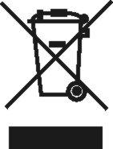Standard batteries and rechargeable batteries that contain hazardous materials are marked with the symbol of a crossed-out waste bin and must not be disposed in the household waste. As a consumer, you are required by law to return used standard batteries and rechargeable batteries. You can return your old standard batteries and

rechargeable batteries as hazardous waste at public collection points in your municipality or anywhere where batteries of the relevant type are sold. You can find these markings on batteries that contain hazardous materials: Pb = battery contains lead, Cd = battery contains cadmium,

Hg = battery contains mercury.

## Scale Disposal

Based on the current standard of knowledge, the device contains no special environmentally hazardous materials. This product must not be treated as standard waste but must instead be returned to a collection point designated for recycling electrical and electronic devices. You can obtain more information from your municipality, the municipal recycling operations, or from the dealer where you bought the product.

# APPROVAL

## CE marking

The product carries the CE marking

in accordance with the following directives:

EMC Directive: 2014/30/EU

Low Voltage Directive: 2014/35/EU Scale Directive: 2014/31/EU Medical Device Directive: 93/42/EC

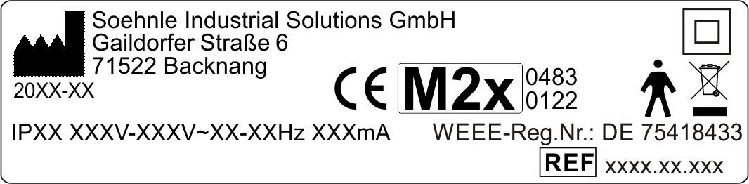

Explanation of symbols:

 EU conformity mark with No. of the "official authority" pursuant to the Medical Device Directive

 Protection class of the product  Part number of the product  Manufacturer of the product

 The user manual must be observed  Do not sit on the device

Class II protected device law. Standard 60601-1, Type B application device  Bumping, crushing, falling, or tripping hazard



* 1. Description of type plate and symbols

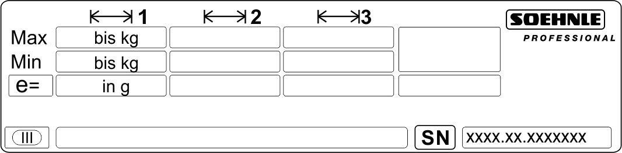

Explanation of symbols:

 Active scale range

Max Maximum load of the weighing range Min Minimum load of the weighing range

e = approval value (indicated increment)  EC Conformity Declaration

* Accuracy class

TCM 128/12-4961 Certification No.

773x Manufacturer's product number

XXXX e.g. 0122, registration No. of the "Official Authority" (this authority performed the initial approval)



**M21**

EC approval mark with model year

SN Serial number of the scale (scale type, model year, sequential number)

 The calibration counter displays how many times the scale was calibrated. The stored counter reading must match the protected calibration counter reading (see sticker) on the housing.

## Explanation of Symbols on the Packaging

 Caution fragile

 Note orientation for transport

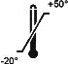 Protect against moisture and wetness Adhere to storage temperature

# SETTING UP THE SCALE

## Scale setup and startup

The scale is fully assembled on delivery.

* Remove the packaging.
* Place the scale on a firm, level surface. Make sure that cables or other objects are not pinched under the scale.
* Align the scale by undoing the foot screws. The air bubble in the spirit level must be right in the centre of the circle.

*For setup locations in Germany, this condition has been met when the floor meets the tolerances specified by DIN 18202 Table 3 row 4.*

*For other countries, the respectively applicable standards may have to be referenced.*

## Mounting the length rod (version 7730.65.002)

The two holders for the length rod are mounted to the length rod with one countersunk screw each (see 1).

1

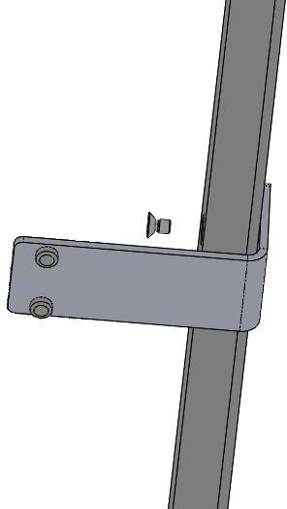



Then the length rod with the two holders is attached to the stand with 2 pan-head screws each (see 2)

2

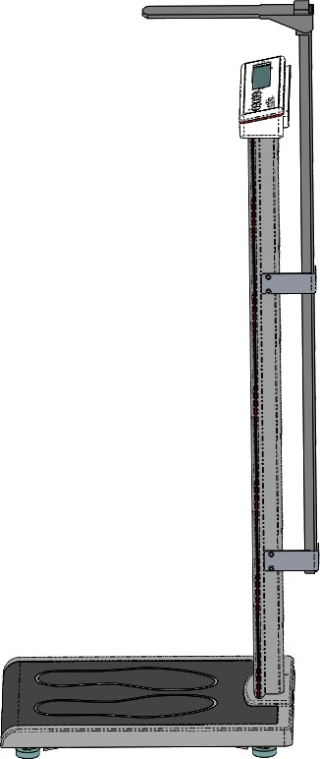

## Power supply

The scale is powered by a rechargeable battery or a mains unit.

* + 1. Connect power supply unit
       1. Insert the power supply cable into the connecting socket on the rear of the scale.
       2. Plug the mains unit into a power supply socket.

Make sure the power outlet remains easily accessible.

Only for rechargeable battery version:

* + - 1. Charge the rechargeable battery for 5 hours prior to initial startup. The blue pilot lamp in the housing light up while the battery is charging. The LED expires as soon as the battery is fully charged.

The scale must only be operated by staff.

The scale is not intended for operation by the patient.

## Switch on





## Weighing



Press the ON/OFF button while the scale is not under load.

After the test routine has completed, the calibration counter is displayed briefly followed by the zero in the display.

Calibration counter: No error messages. The scale is ready for weighing.

Carefully step onto the weighing platform of the scale.

The weight is displayed automatically after a load is placed onto the scale.

Weighing requires both legs of the patient to be positioned on the weighing platform of the scale.

## Tare

Manual tare

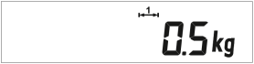

Position the item onto the weighing platform followed by pressing the tare key.

Manual tare entry

This requires "Manual Tare Entry" to be assigned to the function key in setup mode. See user mode 3710 for programming the function key (see separate instructions 470.702.099)

→ UCAL 4 Pos. 02 = value 4.

Program the value with the tare key or the function key. Briefly pressing increments the value. Pressing and holding the key increases or decreases the reading.

 The programmed value is saved by pressing the print key.

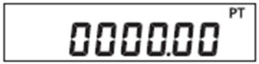



Delete tare

Press the zero reset key to delete the tare.

Tare info



Pressing and holding the zero reset key displays the tare weight. Briefly pressing deletes the tare weight; pressing and holding until the weight display blinks does not delete the tare weight.

Dialysis function (interim tare function)

The function key can be programmed with a dialysis function.

See user mode 3710 for programming the function key (see separate description 470.702.099) → UCAL 4 Pos. 02 = value 5.

Unknown tare values are added to the stored tare value without changing the net display.

After the function key is pressed, the display shows "hold".

Place additional tare weight or remove tare weight from platform. The new tare value is stored with the print key.



## Hold function

The hold function is assigned to the function key in setup mode. See user mode 3710 for programming the function key (see separate description 470.702.099) → UCAL 4 Pos. 02 = value 1.

In weighing mode, the hold function is enabled by pressing the function key.



The following hold functions are available to freeze weight data. Default is "0".

The hold function is programmed in setup mode (see separate description 470.702.099 user mode 3710) → UCAL 1 Pos. 02.

|  |  |  |
| --- | --- | --- |
| Hold mode | Function | Cancel function |
| 0 | Inactive |  |
| 1 | Hold at rest | On/Off key |
| 2 | Hold at rest | Removal of load from scale |
| 3 | Max. value | On/Off key |
| 4 | Max. value | Removal of load from scale |

|  |  |  |
| --- | --- | --- |
| 5 | Slave display | On/Off key |
| 6 | Slave display | Removal of load from scale |

The hold mode is disabled with the function key.

## Printing / IT interface (with optional RS232 interface)

A printer or IT / PC can be connected to the standard terminal with the optional RS232 serial interface.

The interface function is configured as per the separate description 470.702.099 user mode 3710 and 470.508.077 Data interface 3710.

A printout of the data record transmission can be initiated with the print key or with an IT request.

## Alibi memory (option for verifiable data transmission)

 The alibi memory is enabled in setup mode (see separate description 470.702.099 User mode 3710). When the alibi memory is enabled, an arrow points to the corresponding symbol. The arrow blinks as soon as the entered threshold value for the full message has been reached.

The entry is saved into alibi memory by pressing the print key or via IT request. Either the print image or the IT data record must be configured appropriately (separate description 470.508.077 Data interface).

Data is retrieved from alibi memory (display/print entries) in setup mode:

Press and hold Print together with the ON/OFF key for 5 seconds until



 is displayed.

Press the tare key until  is displayed and enter with the print key.



Then continue paging with the tare key to position 03 and enter with the print key.

The number of the last saved data record is displayed. By changing the sequential number with the arrow keys (tare / function key), each data record can be retrieved and displayed by pressing the print key. The selected data record is paged through as follows:





|  |  |  |
| --- | --- | --- |
| Display output | Definition | |
|  | Sequential number of the alibi entry | |
|  | Scale type | Serial number of the measurement location |
|  | Year |
|  | Sequential number |
|   kg | Gross or net alibi | |
|   kg T | Tare with alibi identifier | |

Continue paging up or down with the arrow keys (tare / function key) Display mode is closed with the print key.



Press zero reset key,  is shown in the display.

Close and save the setting: Briefly press the print key together with the zero reset key. The display switches back to weighing mode.

## PLU memory (e.g. saving various tare weights)

Note:

This function requires the optionally available (from factory only) RS 232 interface (order No.: 2563.41.004). The interface cannot be retrofitted.

The PLU memory (product lookup) has 100 storage locations. The interface is used to write to PLU memory. Each PLU contains a name, unit weight, and tare weight. The command

<K080Kplu;name;unit;tare> is used for this purpose.

* PLU is the PLU number; the value ranges from 001 to 100
* Name; up to 20 characters (the first 7 characters are displayed)
* Unit is the unit weight; the value is entered in g and with a period as the decimal separator
* Tare is the tare weight; the value is entered in g and with a period as the decimal separator

The product CD included in the supplied scope contains the PC software PLU Memory, which is used to transfer the contents from the PC to the scale terminal.

The function key for PLU memory is enabled in setup mode.

See user mode 3710 (see separate description 470.702.099) → UCAL 4 Pos. 02 = value 9.

Using the PLU:

Enable PLU memory by pressing the function key. PLU and the PLU number is shown in the display.

Press the tare key or the function key to enter the desired PLU number.

Save the selected PLU memory with the print key. The name is briefly shown in the display.

Press the ON/OFF key to return to weighing mode.

## Infant weighing

An adult steps on the scale.

* Display e.g. »57.6 kg« Press the tare key.
* Display returns to »0.0 kg« The adult steps off the scale ...
* Display e.g. »-57.6 kg«

...and then steps back on the scale together with the child.

* The display now shows the weight of the child, e.g. »5.1 kg«

## Zero reset



## BMI-function

Press the Zero rest key to correct small variances from the zero point,

e.g. due to dirt collecting on the scale.

Zero set range verifiable and non-verifiable: -1 to +3% of the weighing range.

Load the scales.

Press the F function key. (Default setting of the function key) Display shows body size, standard 170 cm (H: 170.)

Changes possible with T or F key. Confirm entry by pressing Enter.



Display will change between weight and BMI value (bl:26.2 - 82.8kg).

F key returns to the entry of body size.

To end the BMI function unload the scales or press the ON/OFF key.



## Operating the length gauge (version 7730.65.002)

Carefully push the length gauge upwards and carefully fold out the extension arm. Then slowly push the unfolded length gauge down again until the extension arm rests on the head of the person to be measured (o not press down). The height in cm can now be read off the attached scale.

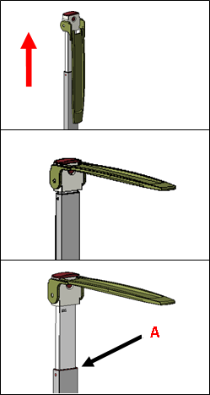Measuring over 131 cm:

1. Pull out the rod
2. Position the head piece to horizontal position
3. Height reading can be taken at A point

Measuring under 131 cm:

|  |
| --- |
|  |
|  |
| **B** |

1. Fold the plate and press the buckle
2. Pull down head piece while buckle is pressed
3. Height reading can be taken at B point.

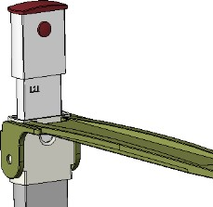

Tollerance: ± 10 mm (e.g. for a body height of 180 cm, a body height of 179 cm can also be measured by pushing the headpiece downwards).

## Switch off / Shutting down safely

 Press the ON/OFF key to switch off the scale.

This is possible immediately if the scale is empty and the displayed weight is 0.



Press and hold the ON/OFF key for 5 seconds if a load is on the scale.

The device shuts down by pressing the key. The device is fully disconnected from mains by pulling the power plug from the power outlet. This ends operations safely.

Note:

If »0.0 kg« is displayed, the scale automatically shuts down after a predefined time. The display is reenabled with the ON/OFF key.



# MALFUNCTIONS – CAUSES AND REMEDIES

DISPLAY REMEDIES



The scale automatically goes to zero Remove load from platform.

after it is switched on. If the scale is Remove any dirt. If the scale does outside of the intended tolerance range, not display zero after several

the display shows -0-. seconds, please contact your service partner.

Underload: only the lower dashmarks

appear in the display.

Switch off the display. The zero

point is automatically reset during startup.



Overload: only the upper dashmarks Remove load from scale or switch appear in the display. Maximum weighing scale off and then back on. The range exceeded. zero point is automatically reset.

Part weight too small. Incorrect UCAL setting.



Under or over zero reset limit.

Check the floor and the leveling of the weighing platform. Check scale for a force shunt. Contact your service partner if the error message persists after the realignment.

Tare not possible without load on scale,

when not at rest, or with overload.



Printing is not possible with overload or underload.



Switching between kg/lb is locked.

Remain standing still, or bring

the positioned weight to rest, or switch the scale off and then back on without a load.

Only for rechargeable battery / battery version



Battery is low. Approximately 30 minutes Connect unit with power supply of operating time remains. and start charging, resp. change

the batteries.

Battery is fully discharged. Connect unit with power supply and start charging, resp. change the batteries.

Contact your Soehnle Professional service partner if the malfunction is not remedied or other error messages are displayed.

# NOTICES CONCERNING ELECTROMAGNETIC COMPATIBILITY

|  |  |  |
| --- | --- | --- |
| Guidelines and Manufacturer Declarations / Electromagnetic Emissions | | |
| The type series 7730.65 scale is designated for operations in the electromagnetic environments indicated below. Customers or users of type 7730.65.xxx scales should ensure that the scale is used in such an environment. | | |
| Emissions Measurements | Compliance | Electromagnetic environment - guidelines |
| HF emissions law. CISPR 11 | Group | The 7730.65 scale uses HF energy strictly for its internal FUNCTION. Its radiated HF is therefore very low,  and it is highly unlikely that nearby devices are interfered with. |
| HF emissions law. CISPR 11 | Class B | The 7730.65 scale is intended for use in all facilities including residential areas and those directly connected to a public utility  grid that also supplies buildings used for residential purposes. |
| Harmonics law. IEC 61000-3 -2 | Class A | The scale is intended for use in all facilities including residential areas and those directly connected to a public utility grid that also supplies buildings used for residential purposes. |
| Voltage fluctuations/ flickering law. IEC 61000-3-3 | fulfilled | The 7730.65 scale is intended for use in all facilities including residential areas and those directly connected to a public utility  grid that also supplies buildings used for residential purposes. |

The scale is subject to special precautionary measures with respect to EMC and must be installed and operated in accordance with the EMC instructions contained the SUPPORTING DOCUMENTATION. Portable and mobile HF communication devices can influence the scale if they are positioned too closely.



|  |  |  |  |
| --- | --- | --- | --- |
| Guidelines and Manufacturer Declarations / Resistance to Electromagnetic Interference | | | |
| The type series 7730.65 scale is designated for operations in the electromagnetic environments indicated below. Customers or users of type 7730.65.xxx scales should ensure that the scale is used in such an environment. | | | |
| Interference resistance tests | IEC 60601 Test level | Compliance level | Electromagnetic environment - Guidelines |
| Electro-static Discharges (ESD) law. IEC 61000-4-2 | + 6 kV contact discharge (indirect)  + 8 kV  Airborne discharge | + 6 kV contact discharge  + 8 kV  Airborne discharge | Floors should consist of wood or concrete or be covered with ceramics. When the floor is covered with synthetic materials, the relative humidity should be no less than 30 %. |
| Fast transient electrical interference/bursts law. IEC 61000-4-5 | + 2 kV  for grid cables | + 2 kV  for grid cables | The quality of the power supply should correspond to a typical commercial or hospital environment. |
|  | + 1 kV  for input and output cables | + 1 kV  for input and output cables |  |
| Surges law. IEC 61000- 4-5 | + 1 kV  Voltage outer conductor - outer conductor | + 1 kV  Voltage outer conductor - outer conductor | The quality of the power supply should correspond to a typical commercial or hospital environment. |
|  | + 1 kV  Voltage outer conductor - ground | Not applicable |  |
| Voltage drops, momentary interruptions and fluctuations of the power supply law. IEC  61000-4 -11 | < 5% LT  for ½ period  (> 95 % collapse)  40% LT  for 5 periods  (60 % collapse)  70% LT  for 25 periods  (30 % collapse) | < 5% LT  for ½ period  (> 95 % collapse)  40% LT  for 5 periods  (60 % collapse)  70% LT  for 25 periods  (30 % collapse) | The quality of the power supply should correspond to a typical commercial or hospital environment.  If the user of the 7730.65 scale demands continued function even when the energy supply is interrupted, we recommend powering the 7730.65 scale with an uninterruptible power supply or a battery. |
|  | < 5% LT  for 5 sec.  (> 95 % collapse) | < 5% LT  for 5 sec.  (> 95 % collapse) |  |
| Magnetic field at the | 3 A/m | 3 A/m | Magnetic fields at mains frequency |
| supply frequency |  |  | should correspond to the typical values |
| (50/60 Hz) law. IEC |  |  | as found in commercial and hospital |
| 61000-4-8 |  |  | environments. |
| NOTE: LT is the mains alternating voltage before the test level is applied | | | |

|  |  |  |  |  |  |
| --- | --- | --- | --- | --- | --- |
| Guidelines and Manufacturer Declarations / Resistance to Electromagnetic Interference | | | | | |
| The type series 7730.65 scale is designated for operations in the electromagnetic environments indicated below. Customers or users of type 7730.65.xxx scales should ensure that the scale is used in such an environment. | | | | | |
| Interference resistance tests | | IEC 60601 Test level | Compliance level | Electroma | gnetic environment - Guidelines |
|  | |  |  | Portable and mobile radios should not be used at a distance to the 7730.65 scale including the cable smaller than the recommended protective distance calculated based on the equation applicable for the transmitted frequency. | |
| Conducted HF interferences  law. IEC 61000-4-6 | | 3 Veff  150 kHz to 80 MHz | 10 Veff  150 kHz to 80 MHz | Recommended protective frequency:  *d* = 0.4 P | |
| Radiated HF interference law. IEC 61000-4-3 | | 3 V/m  80 MHz to 2.5 GHz | 10V/m  26 MHz to 2.7 GHz | *d* = 0.4 P  for 80 MHz to 800 MHz  *d* = 0.7 P  for 800 MHz to 2.7 GHz | |
|  | |  |  | with P as the nominal output of the transmitter in watts (W) as per the manufacturer's specifications and *d* as the recommended protective distance in meters (m). | |
|  | |  |  | The field strength of stationary radio transmitters should for all frequencies pursuant to an on-site test be lower than the compliance level. | |
|  | |  |  | Interference is possible in the vicinity of devices displaying the following pictogram. | |
|  | |  |  | ((( ))) | |
| NOTE 1:  NOTE 2: | The higher frequency range applies for 26 MHz and 800 MHz These guidelines may not apply in all cases. The propagation of  electromagnetic phenomena is influenced by the absorption and reflection of buildings, objects and persons. | | | | |
| 1. The field strength of stationary transmitters such as base stations and mobile phones and mobile land transmitters, amateur radios, AM and FM broadcast and television transmitters cannot be theoretically predicted accurately. A study of the location should be considered in order to determine the electromagnetic environment of stationary transmitters. If the measured field strength at the location where the device is used exceeds the above compliance level, the device should be monitored in order to demonstrate the intended function. If unusual performance characteristics are observed, additional steps may be required such as a change or another location for the device. 2. The field strength should be less than 3 V/m above the frequency range of 150 kHz to 80 MHz. | | | | | |





|  |  |  |  |
| --- | --- | --- | --- |
| Recommended safety clearances between portable and mobile HF telecommunication devices and scales of type series 7730.65 | | | |
| The type series 7730.65 scale is designated for operations in the electromagnetic environments indicated below. Customers or users of type 7730.65.xxx scales can help to avoid electro-magnetic interference by complying with the  minimum distance between portable and mobile HF telecommunications devices (transmitters) and the type 7730.65 scales - depending on the output cable of the communications device, as indicated below. | | | |
| Nominal output of the transmitter W | Protective distance as a function of transmission frequency m | | |
|  | 150 kHz to 80 MHz | 80 MHz to 800 MHz | 800 MHz to 2.5 GHz |
|  | d = 1.2 *P* | d = 0.35 *P* | d = 0.7 *P* |
| 0.01 | 0.12 | 0.04 | 0.07 |
| 0.1 | 0.38 | 0.11 | 0.22 |
| 1 | 1.20 | 0.35 | 0.70 |
| 10 | 3.79 | 1.11 | 2.21 |
| 100 | 4.0 | 3.50 | 7.00 |
| For transmitters whose nominal output is not indicated in the above table, the distance can be determined by employing the equation associated with the relevant column, wherein *P* is the nominal output of the transmitter in watts (W) as per the transmitter manufacturer specifications.  NOTE 1:  In order to calculate the recommended protective distance for transmitters in the frequency range from 80MHz to 2.5 GHz, an additional factor of 10/3 was used to reduce the probability that a mobile/portable communications device brought into the patient's vicinity causes interference.  NOTE 2:  These guidelines may not apply in all cases. The propagation of electromagnetic phenomena is influenced by the absorption and reflection of buildings, objects and persons. | | | |

## Soehnle Industrial Solutions GmbH

Gaildorfer Straße 6 DE-71522 Backnang

Telefon: +49 (0) 71 91 / 34 53 – 220

Telefax: +49 (0) 71 91 / 34 53 – 211

E-Mail: [info@sis.gmbh](mailto:info@sis.gmbh) [www.soehnle-professional.com](http://www.soehnle-professional.com/)